**الاسم و اللقب :............................. اللغة الانجليزية    
Text :  
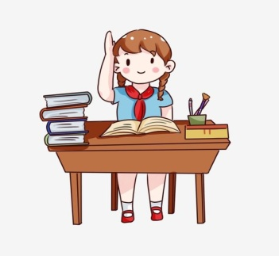 Hi! my name is bochra i’m 8 years old,i live in ain temouchent , i’m 5th year pupil at maghni pramiry school , my father are a doctor at the hospital .and my mom are a teacher and i have a little sister.In my free time i like to learn a new thing and educate my self.   
  
 Questions:  
  
1- Read the text then answer the questions:  
-how old is bochra?  
...............................................................  
-where does bochra live?  
...............................................................  
-is her father a teacher?  
...............................................................  
  
2-answer with true or false :**

**-her mother is doctor ........  
-she has two sister ........  
-bochra is pupil at primary school ........  
3- Match  
Bochra Teacher  
Father 8 year old  
Mother Maghni  
Primary school Doctor**

**4-Reorder the following words :  
1-is /my/bochra/name.  
…………………………………………………  
2-Love/learn/new/I/to/English.  
………………………………………………  
5- written expression :  
In 04 lines describe your school   
and use this following words to help you:  
Small , big , nice , beautiful , class, school yard , teachers   
  
 My school is very nice place……………………….. ………………………………………………………………………………………………………………………………………………………………………………………………………………………………………………………………………………………………………………………………..**